Topics:

1. Remind of process 2
2. PROCEDURE 3
2.1 Run transaction MRN2 3
2.2 Extract slow Moving Good by a query 7
2.3 Export to Excel : 9
2.4 post provision manually in fi 10

Remind of process

Local & Group inventory value must be depreciated, according to a percentage applied to material with a "slow moving" inventory. Specific rules must be applied to Group & Local values.

Inventory Depreciation will be performed using the Range of Coverage method. This method is used to apply a percentage of depreciation, dependant on the number of months represented by the Inventory Quantity at the period of depreciation.

Devaluation Rate by range of coverage can be entered individually by Company Code and by Valuation Area. By convention, we will use :

- Company Code level to reflect group rules
- Valuation area level to reflect local rules.

Steps :

- Identify each month the slow moving materials (last month final quantity representing 5 years of consumption).

All material considered as slow moving are depreciated at 100% of their value, this provision is posted each month.

- At the end of the year, the slow moving goods are valued at a price calculated as follows :

weight of the slow moving part * price per kg of a 'reference' scrap material (e.g. Copper if the part is mainly made of copper).

This is done by an external process (query to extract slow moving goods, plus Excel to calculate value)

Remark : When running the Range of Coverage program at the end of the year, it should be paid attention to the following :

- Select the valuation level to be applied (Company Code for Group, Valuation Area for local)
- If Valuation Area, specify which one
- Define base price in accordance : current material price if Group, Tax Price 1 if Local

The list will present valuation differences per material. FI posting for revaluation (either local of group) will be done manually.

PROCEDURE

Run transaction MRN2
Objective : Update the Material Master Record
View Accounting 2 : Devaluation indicator is increased by 1 if the material is slow or non-moving.

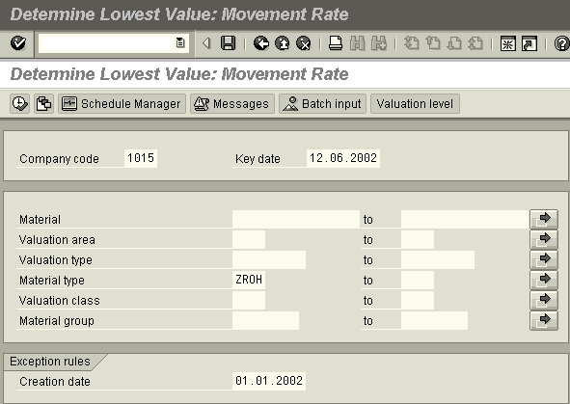

- Company Code level to reflect group rules
- Valuation area level to reflect local rules.
Make the operation
for each material type
ZROH, ZPRO …

This field enables you to not devaluate material created after this date.

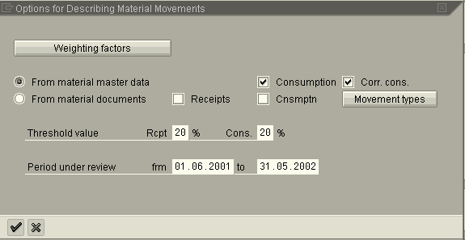

Period : 12 previous month
Threshold value : - 20% : 1 year
- 40% : 2 year (…)

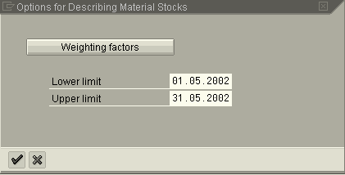

Previous Month for a monthly depreciation
Previous Year for a year-end process depreciation

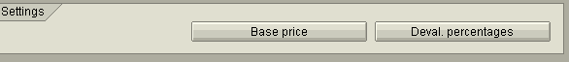

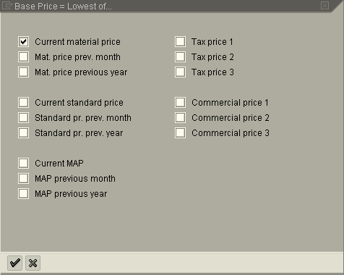

Define price with the according depreciation level :

- Current material price for the Group
- Tax Price 1 for local

100% for Depreciation
indicator >1

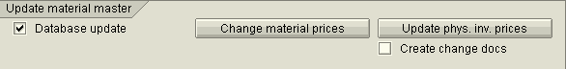

No update !

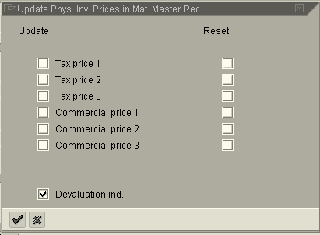

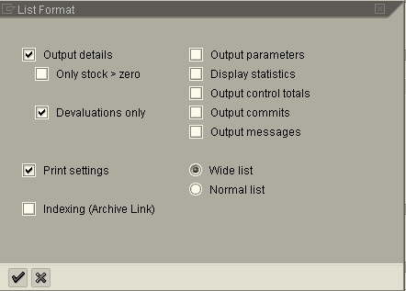

Run the program and analyze the result :
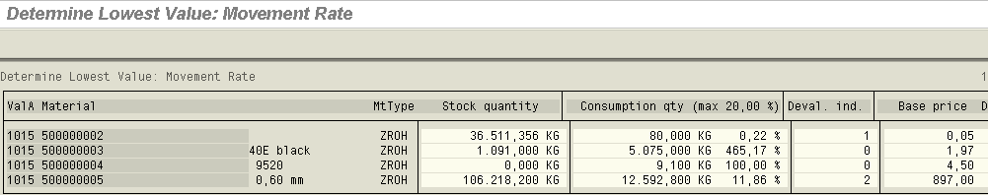

Devaluation indicator which will be updated in the material Master Record (View accounting 2)

Example :

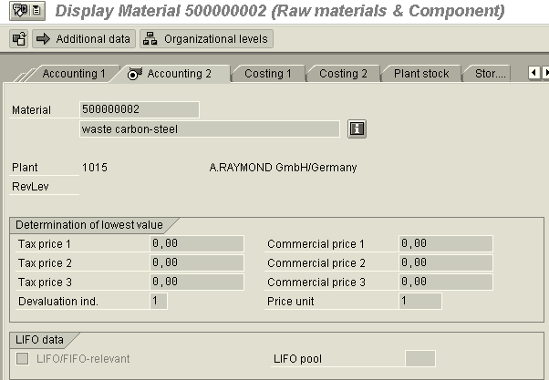

Extract slow Moving Good by a query
Run transaction SQ01

Select the User group Z_CO

Run the query Z_CO_00_DEP of the user group Z_CO

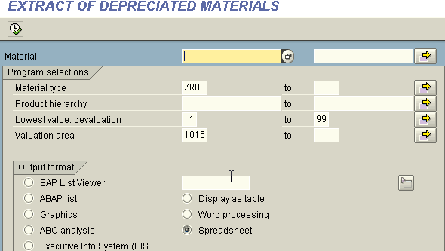

Selection on material type & with the lowest value code.
Valuation area 1015

Select the relevant output format.

E.g.:
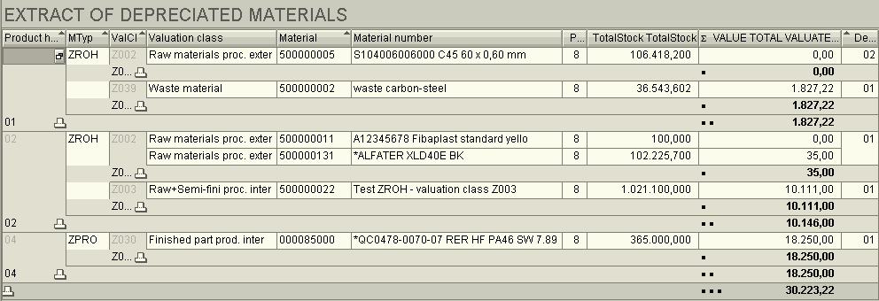

Result of the query is correct :
Material Master for Product 50000002 : Previous Period Valuation.
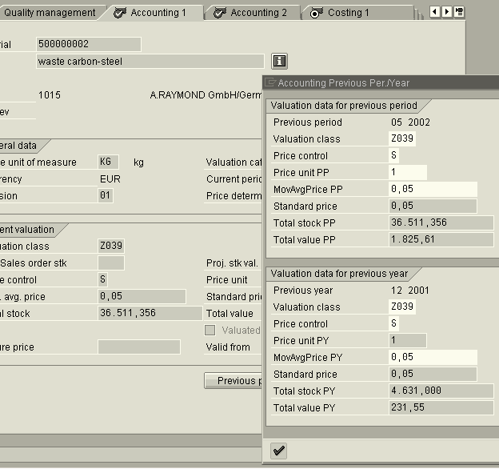

Export to Excel :
List -> Export -> Local File

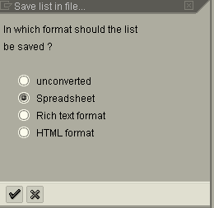

Select a folder to store the file : under “name”.xls

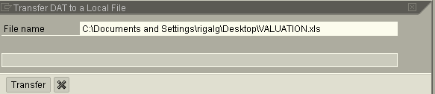

post provision manually in fi
The posting must be done by Product Line .

End of Month :
G/L Accounts postings :
- Debit :
  - 782080 : Provision for Depreciation of Inventory Manufactured
  - 782081 : Provision for Depreciation of Inventory Brokered
  - 782082 : Provision for Depreciation of Inventory Raw Material
- Credit
  - 136080 : Reserve on Brokered Finish Goods
  - 136180 : Reserve on Manufactured Finish Goods
  - 136580 : Reserve on Raw Material

Beginning of following month
Reversal of the posting
- Debit
  - 136080 : Reserve on Brokered Finish Goods
  - 136180 : Reserve on Manufactured Finish Goods
  - 136580 : Reserve on Raw Material

- Credit :
  - 782190 : Write back of Provision for Depreciation of Inventory Manufactured
  - 782191 : Write back of Provision for Depreciation of Inventory Brokered
  - 782192 : Write back of Provision for Depreciation of Inventory Raw Material

!!!! On P&L accounts, the posting has to be done per product line!!!!

Example : FB50 on product line 01

